Hugh Brennan
CITP 190
Project 2

Screen Capture for Project 2-1

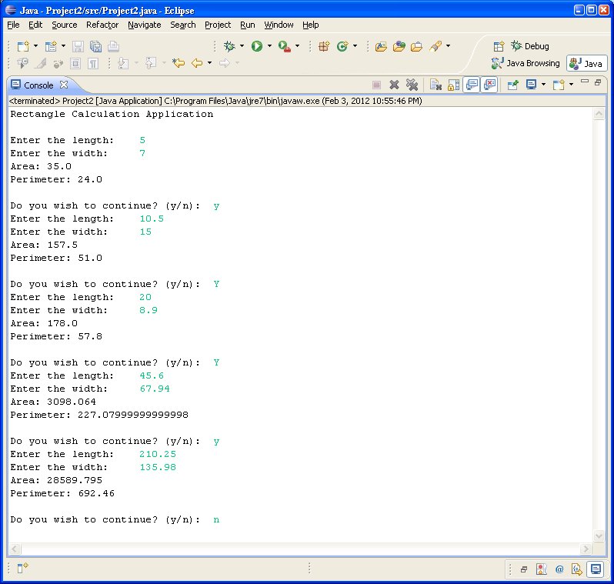

Screen Capture for Project 2-1
Welcome to the Letter Grade Converter

Enter numerical grade: 100
100
Letter grade: A

Do you wish to continue? (y/n): y
Enter numerical grade: 92
92
Letter grade: A

Do you wish to continue? (y/n): y
Enter numerical grade: 88
88
Letter grade: A

Do you wish to continue? (y/n): y
Enter numerical grade: 87
87
Letter grade: B

Do you wish to continue? (y/n): y
Enter numerical grade: 85
85
Letter grade: B

Do you wish to continue? (y/n): y
Enter numerical grade: 80
80
Letter grade: B

Do you wish to continue? (y/n): y
Enter numerical grade: 79
79
Letter grade: C

Do you wish to continue? (y/n): y
Enter numerical grade: 77
77
Letter grade: C

Do you wish to continue? (y/n): y
Enter numerical grade: 67
67
Letter grade: C

Do you wish to continue? (y/n): y
Enter numerical grade: 66
66
Letter grade: D

Do you wish to continue? (y/n): y
Enter numerical grade: 60
60
Letter grade: D

Do you wish to continue? (y/n): y
Enter numerical grade: 59
59
Letter grade: F

Do you wish to continue? (y/n): y
Enter numerical grade: 45
45
Letter grade: F

Do you wish to continue? (y/n): n

